1. Update Eclipse to version 12 or above. Below is the link for downloading the JDK 14 version, please select the one for your own operational system.

<https://www.oracle.com/java/technologies/javase-jdk14-downloads.html>

1. Create a Java Project

Project name: your own name

JRE – use an execution environment JRE: JavaSE-12 (or above)

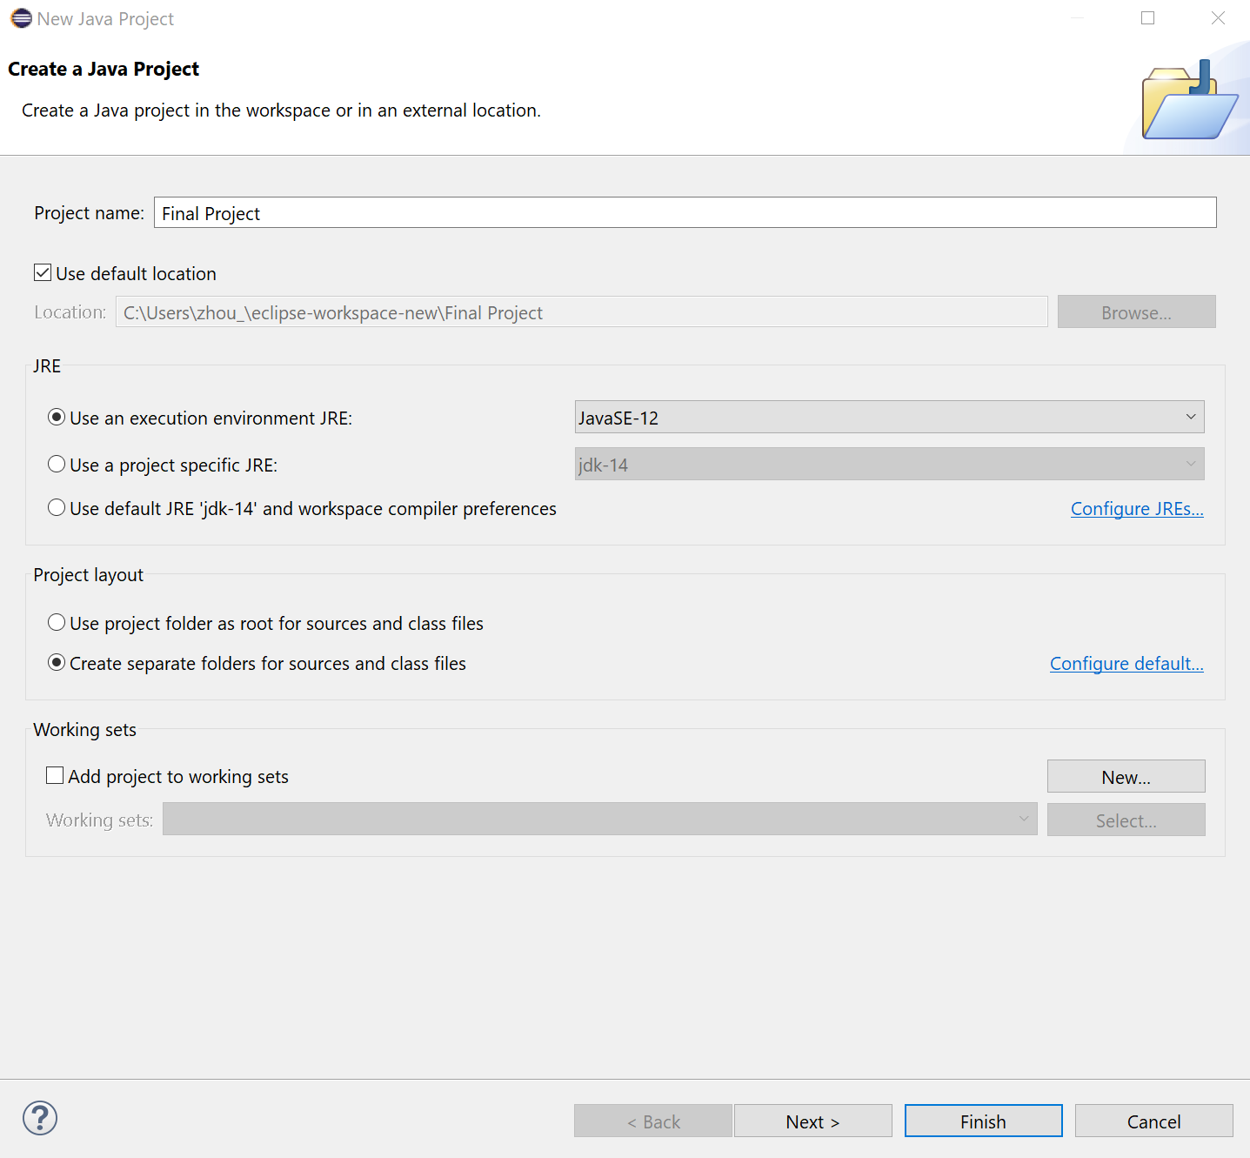

1. Copy all classes and sourcing files into correct paths.

All java classes under src folder

All source files (cvs files) under Project folder.

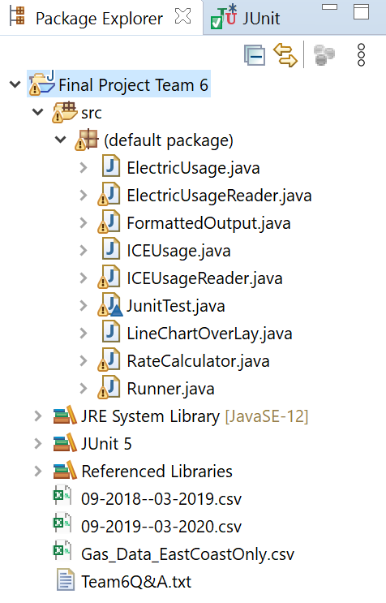

1. Import library folder files into correct path.

Right click project name 🡪 Build Path 🡪 Configure Build Path

Under Libraries Tab, left click Classpath 🡪 Add External JARS 🡪 import provided Library folder

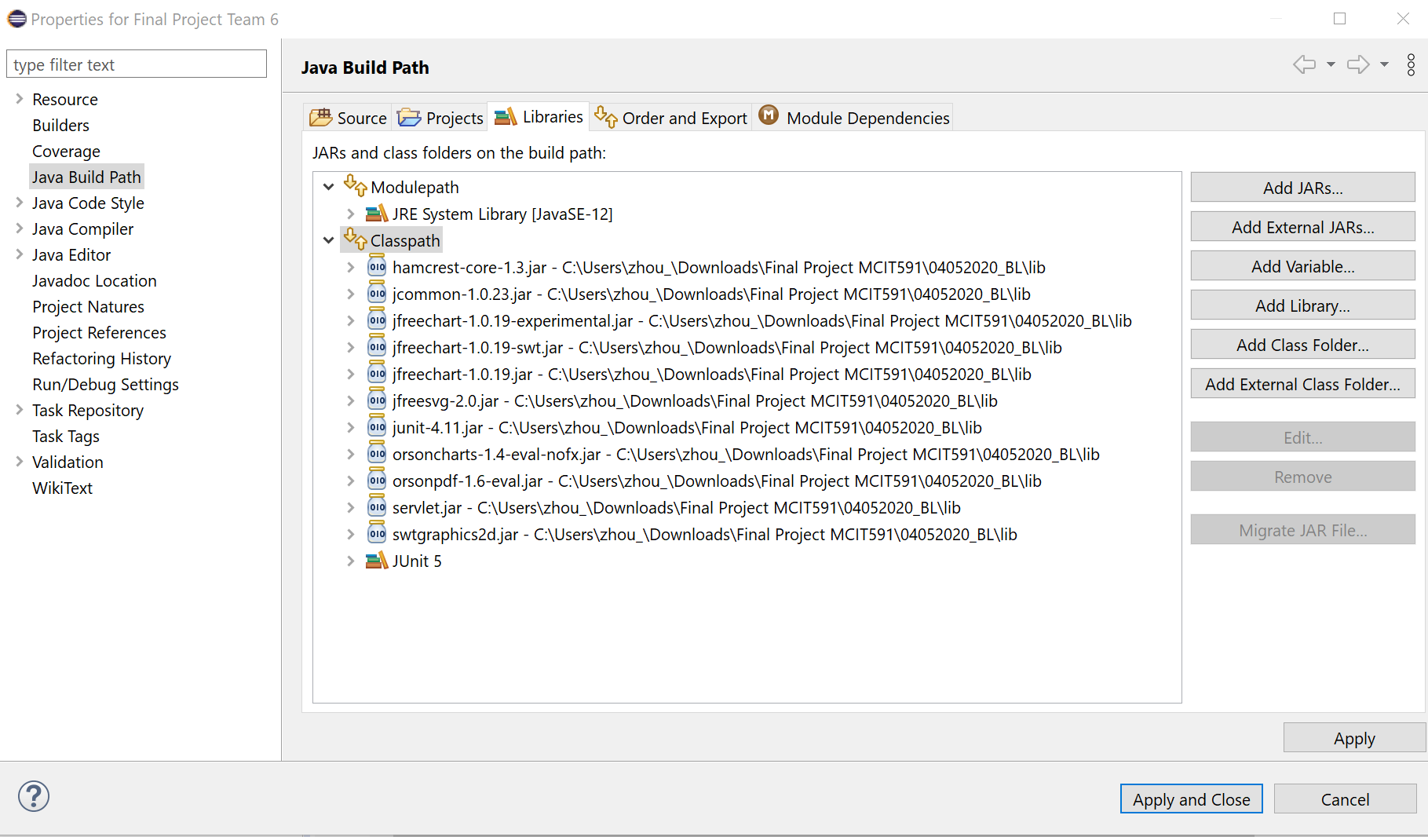

1. Ready to run.